Answers
Task 1
The following shows a database table named Customers. This is used in an activity centre. All activities need to cost less that £100 and activities must be 2 hours or less.
Table name: Activities
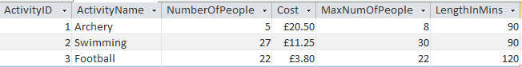
(a) Match each of the fields below with the validation rule that would be most appropriate.
Field |  | Validation rule
ActivityName |  | <100.00
NumberOfPeople |  | [NumberOfPeople]<=[MaxNumOfPeople]
Cost |  | <=120
MaxNumOfPeople |  | Length is 255 characters or fewer
LengthInMins |  | <30
Note: When using access [NumberOfPeople]<=[MaxNumOfPeople] will not work in the “Validation Rule” box for the particular field. It instead needs to be entered as a validation rule for the whole sheet – change this on the “Property Sheet” which is found when you are in the design view for the table.
(b) ActivityID is the primary key for the table.
Explain what the term primary key means.
Other fields are not unique for every record. For example, the length of an activity may be the same for many records. The activity ID will be unique for every record. This is chosen as the primary key allowing each record to be identified.

Task 2
Two tables, tblEvent and tblPupil, are shown below.
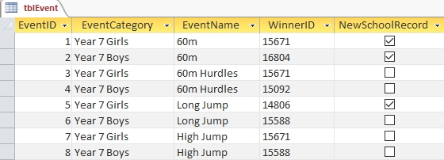
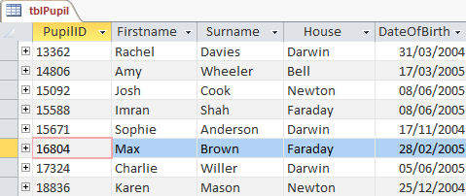
1. Write SQL statements to:
(a) select the “Firstname”, “Surname” and “DateOfBirth” columns from tblPupil.
SELECT Firstname, Surname, DateOfBirth
FROM tblPupil
(b) select the “EventCategory” and “EventName” columns from tblEvent for which new school records were set.
SELECT EventCategory, EventName
FROM tblEvent
WHERE NewSchoolRecord = True
(c) select all columns from tblPupil for pupils in Darwin, Faraday or Bell.
SELECT *
FROM tblPupil
WHERE House = 'Darwin' OR House = 'Faraday’ OR House = 'Bell' or alternatively, the WHERE clause could be written as follows:
WHERE House IN ('Darwin', 'Faraday', 'Bell')

(d) select all columns from tblEvent for which for which the Event category is Year 7 girls and the event name is either 60m or 60m Hurdles.
SELECT *
FROM tblEvent
WHERE(EventCategory = 'Year 7 Girls') AND
((EventName = '60m') OR (EventName = '60m Hurdles'))

2. List the data that could be displayed after executing the following SQL queries on the database.
(a) SELECT FirstName, Surname, House
FROM tblPupil
WHERE House = 'Darwin'
FirstName | Surname | House
Rachel | Davies | Darwin
Sophie | Anderson | Darwin
Charlie | Willer | Darwin

(b) SELECT EventCategory, EventName
FROM tblEvent
WHERE EventName = 'Long Jump' OR EventName = 'High Jump'
EventCategory | EventName
Year 7 Girls | Long Jump
Year 7 Boys | Long Jump
Year 7 Girls | High Jump
Year 7 Boys | High Jump
Task 3
(a) Write an SQL statement to sort tblEvents in Task 2 into ascending order by EventCategory, displaying only the fields EventCategory, EventName and WinnerID.
SELECT EventCategory, EventName, WinnerID
FROM tblEVENT
ORDER BY EventCategory
(b) Write an SQL statement to sort tblPupil in Task 2 into descending order by Surname, displaying only the fields Firstname and Surname
SELECT Firstname, Surname
FROM tblPupil
ORDER BY Surname DESC

Task 4
The following table, named Passengers, shows the data for passengers who have checked in for a flight.
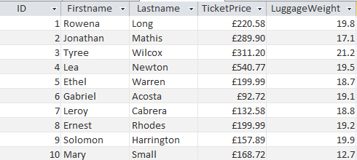
(a) Write an SQL statement to show the total value of all tickets for the flight.
SELECT SUM(TicketPrice) FROM Passengers
(b) Write an SQL statement to show the total check in luggage weight.
SELECT SUM(LuggageWeight) FROM Passengers
(c) Write an SQL statement to count the number of passengers on the flight.
SELECT COUNT(ID) FROM Passengers
Any field could be counted however, it makes sense to count the ID as this field is guaranteed to have data present for every record.

